
Nombre: Período: Fecha: 4B vocab

¿Quieres ir conmigo?
Español 1

To talk about leisure activities:

dance
concert in the afternoon
party this evening
to be going to + verb this afternoon
to go camping this weekend
to go fishing TO extend, accept, or decline invitations:
to play basketball with me
to play baseball with you
to play soccer I can
to play football you can
to play golf Oh! What a shame!
to play volleyball great!
game, match I’m sorry
I know (how) Hey!
you know (how) What a good/nice idea!
TO describe how someone feels: I want
Tired you want
Happy Would you like?
Sick I would like
Bad, badly I have to___________
Busy Other useful words and expressions:
Sad too
TO tell what time something happens: then
(At) what time? A little

At one (o’clock)
At eight (o’clock)
In the morning
In the evening; at night
Gramática— Shoe verbs, saber vs conocer Práctica:
Jugar: To play (a game or sport)
- I play basketball:
_________________________

- They play tenis: ____________________

- We play volleyball:

- I know how to play golf.

- I know Sra. Ríos y Sra. Lorgan

- I want to play soccer.
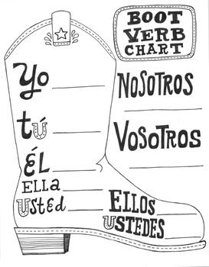

Querer: to want
Saber: to know

Conocer: to know

